**2103 Vermont Street, N.E.**

**Albuquerque, New Mexico 87109**

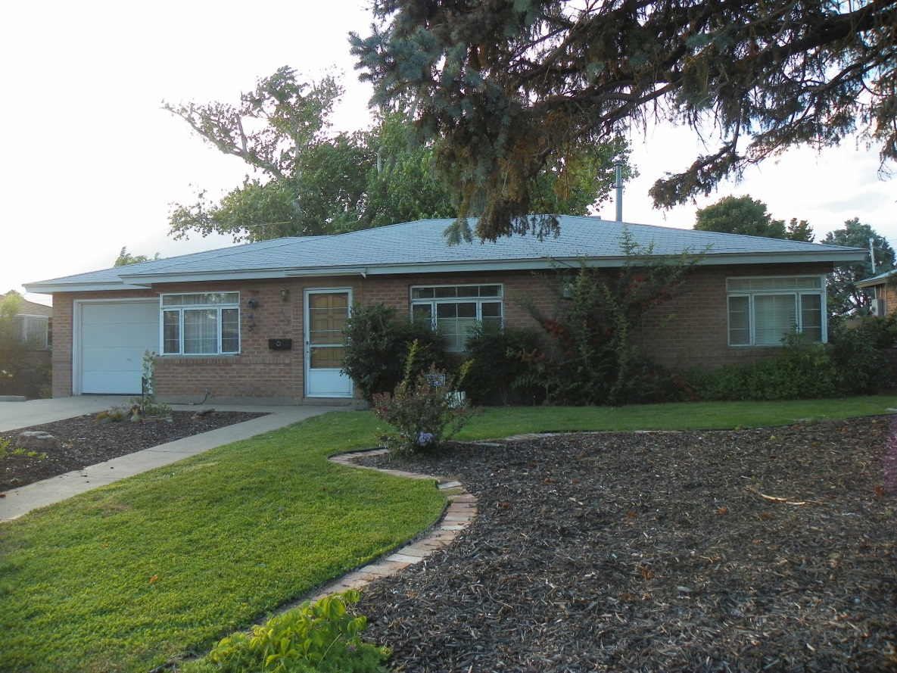

Adorable 3-bedroom, 1-3/4 Bath home in the Hoffmantown area by Menaul & Wyoming. Just a few blocks from the Albuquerque Rose Garden and Tony Hillerman Library. Large living room and LARGER family room with a wood-burning fireplace. Sunroom with pool table and natural gas grill that stay. Separate laundry room with washer, dryer, and wash basin. Kitchen includes all appliances. BRAND NEW bamboo wood floors in living room and two bedrooms. Master bedroom has carpet. Fully landscaped front and back yards with grass, trees, and bushes. Covered brick patio area in the back yard. 1-Car garage. $50 non-refundable application fee. $1200 per month rent. $1200 security deposit. Pets are welcome with a $200 pet deposit. Call Town and Country Diversified Realty at 503-8199 to make an appointment to see. If calling after hours or on the weekend, please call Debbie Roberts at 350-6398 to make arrangements to see.

