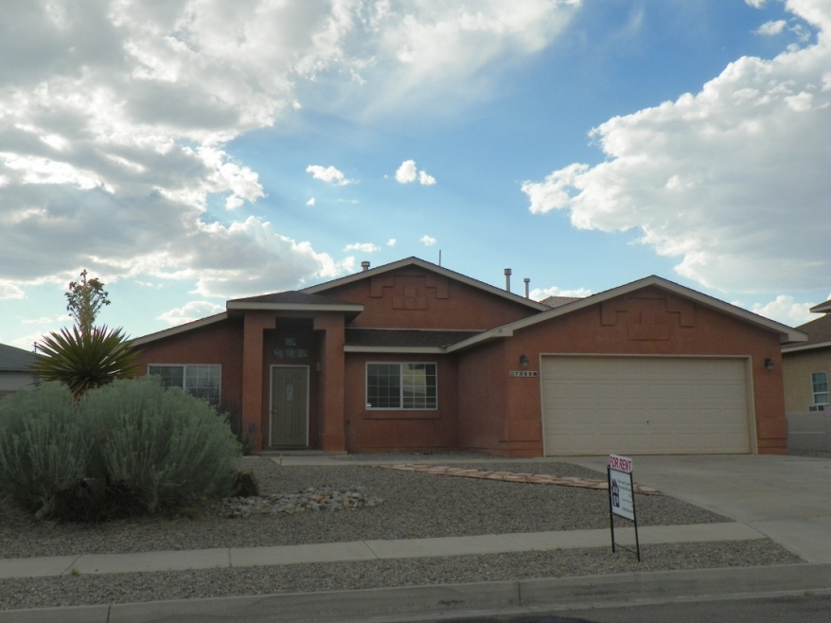
7068 Clark Hills Drive
Rio Rancho, New Mexico

Enchanted Hills Subdivision
1514 Square Feet
4 Bedrooms
2 Bathrooms
2 Living Areas
Gas Fireplace
Eat-In Kitchen with All Appliances
Separate Laundry Room with Front Load Washer & Dryer
Refrigerated Air
2-Car Finished Garage
Large Back Yard with Covered Patio

$1350 Per Month Rent
$1350 Security Deposit
$200 Pet Deposit

