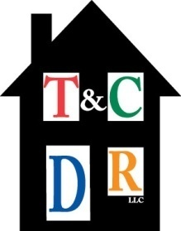
TOWN AND COUNTRY DIVERSIFIED REALTY, LLC
Property Management / Sales
4000 Second Street, N.W. Albuquerque, NM 87107
(505) 503-8199 phone (505) 503-8599 fax

Dear Property Owner:

Thank you for choosing Town and Country Diversified Realty, LLC to manage your rental property. Our company is under the direct supervision of Debbie Roberts, the Qualifying Broker, and Cindy Taibbi who are the members of our management team.

You can rest assured that your property will be well maintained, occupied by respectful and responsible tenants, and all repairs and preventive maintenance will be handled as efficiently as possible.

We screen our applicants by having them complete a very detailed Rental Application. We are also contracted with Verified Information Services who perform a thorough background check including credit reports, criminal history, DMV reports, and local civil court records. We personally verify their employment and check their rental history.

Enclosed are the following forms which need to be completed before we can enter your property into our active inventory and begin the advertising process:

- Property Management Agreement
- Lead-Based Paint Disclosure Before Lease
- Mortgage Certification Statement
- W-9 Form
- Property Information Sheet
- Direct Deposit Authorization
- Landlord Standby (Gas) Service Agreement
- Landlord Standby NMGC Authorization of 2nd Party
- Landlord Standby (Electric) Service Agreement
- Landlord Standby PNM Authorization of 2nd Party

Town and Country requires that $200.00 remains in your property's trust account as maintenance reserve to handle small repairs. We will obtain your authorization for any repairs over $200.00. Our company charges a $200.00 set up fee to process your property and place it in our active inventory. Please make two checks payable to Town and Country Diversified Realty, LLC in the amount of $200.00 each.

We look forward to managing your rental property and developing a long-term relationship.

Debbie Roberts
Qualifying Broker

