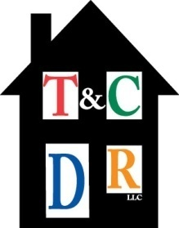
TOWN AND COUNTRY DIVERSIFIED REALTY, LLC
Property Management / Sales
4000 Second Street, N.W. Albuquerque, NM 87107
(505) 503-8199 phone (505) 503-8599 fax

DIRECT DEPOSIT AUTHORIZATION

_____ Enroll _____ Change _____ Terminate

AUTHORIZATION:

I, ____________________________________________, hereby authorize and request that
Town and Country Diversified Realty, LLC initiates deposit entries and initiates, if necessary, withdrawal entries and adjustments for any deposit entries in error to the financial institution and account indicated below.

CUSTOMER INFORMATION:

_____________________________________________________________
Customer Printed Name

_______________________________ ______________________________ Name of Financial Institution Checking or Savings Account

_______________________________ ______________________________ 9-Digit Routing Number Account Number

_____ I do not wish to participate in direct deposit at this time.

______________________________ ______________________________
Owner's Signature Date

ATTACH VOIDED CHECK HERE

