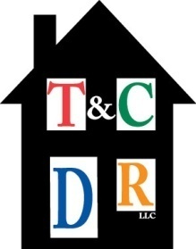
TOWN AND COUNTRY DIVERSIFIED REALTY, LLC
Property Management / Sales
4000 Second Street, N.W. Albuquerque, NM 87107
(505) 503-8199 phone (505) 503-8599 fax

REFERRAL FORM

Owner’s Name: ____________________________________________________________

Property Address: ____________________________________________________________
____________________________________________________________
____________________________________________________________

Contact Number: ____________________________________________________________

Email Address: ____________________________________________________________

Realtor’s Name: ____________________________________________________________

Brokerage Firm: ____________________________________________________________

Address: ____________________________________________________________
____________________________________________________________
____________________________________________________________

Contact Number: ____________________________________________________________

Email Address: ____________________________________________________________

Qualifying Broker: ____________________________________________________________

Contact Number: ____________________________________________________________

Email Address: ____________________________________________________________

